LAKEWOOD POP WARNER
2020 Head Coach Application
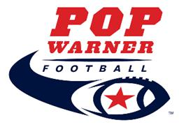
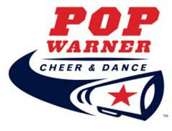

Name:

Address:

Home Phone: |  |  |  |  |  |  |  |  | Mobile Phone:
Email:
Which Position are you applying for?
 | Head Coach |  |  | for |  | Football |  |  |  | Cheer
Which division(s) are you interested in Coaching?
 | Challenger (5‐15 yrs) |  |  |  |  |  |  | Flag (5‐6 yrs)
 | Tiny Mite (5‐6 yrs at 35-75 lbs) & (7 yrs at 35-55 lbs) |  |  |  |  |  |  | Jr Mitey Mite (7‐8 yrs at 45-100 lbs)
 | Mitey Mite (8‐9 yrs at 45-100 lbs) |  |  |  |  |  |  | Jr. Pee Wee (8‐10 yrs at 60-115 lbs) & (11 yrs at 60-95 lbs)
 | Pee Wee (9‐11 yrs at 75-130 lbs) & (12 yrs at 75-110 lbs) |  |  |  |  |  |  | Jr. Varsity (10‐12 yrs at 90-155 lbs) & (13 yrs at 90-135 lbs)
 | 8U (7-8 yrs no weight limit) |  |  |  |  |  |  | 10U (9-10 yrs no weight limit)
 | 12U (11-12 yrs no weight limit) |  |  |  |  |  |  | 14U (13-14 yrs no weight limit)

If NOT selected as a Head Coach would you consider an Assistant Coaching position?

Have you coached youth football/cheer before? Where and what ages?

Have you ever been a Head Coach before?

Have you ever not finished a season that you started? If so why?

If applying for Head Coach, do you have a coaching staff committed to helping you?

List Assistant Coaches:

Football only: Do you understand you will be expected to attend all cheer functions, if you have a cheer team, and that it is your responsibility to have your team attend?

How would you make sure that cheer is included with football and how would you make sure your team attends the cheer competition?

As a Coach what would you like your team to learn from this whole experience?

Have you ever been disciplined by Pop Warner, Lakewood Lancers, or another youth sport league as either a parent or volunteer?

YES NO

If yes, please explain:

I have read and understand the responsibilities noted on the Head Coach Duties handout and if appointed

as a Head Coach agree to perform those duties. (Initial)

The Lakewood Lancers is a Pop Warner organization that is ran entirely by volunteers. The Lakewood Lancers promote safety, health, fitness, teamwork, and academic recognition for all of its young athletes. All Coaches for the Lakewood Lancers are expected to maintain the highest standards in sportsmanship and to display these standards by example for the benefit of their team. After selection and before appointment all Coaches will be required to pass a background check.

I agree to abide by all rules and regulations set forth by the Lakewood Lancers and Pop Warner Little Scholars, Inc. I understand that failure to follow the rules and regulations may result in a fine, suspension and or immediate dismissal.

Signature: Date:

Print Name:

Complete this form in its entirety and submit to Dano Casillas at the following address: coachcasillas@yahoo.com

LAKEWOOD POP WARNER
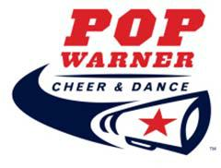
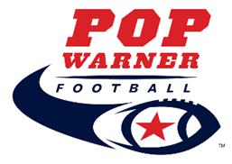
Head Coach Duties

BOARD

- Attend ALL monthly Board Meetings (1 per month and as needed)
- Enforce all Pop Warner and Lakewood Lancers rules and policies
- Remove players, cheerleaders, parents, assistant coaches, and or cheer coaches breaking rules
- Pass on information to parents & coaching staff
- Collect all outstanding paperwork and make sure team gets certified
- Remove players from practice when payment deadlines are not met

COACHING STAFF

- Make sure assistant coaches finish required training & submit application for background check

- Prevent assistant coaches and or parents to help during practice until training and background checks are completed

Train Coaching Staff

- Regarding Pop Warner and Lakewood rules and policies
- Regarding safety and appropriate language for practices, games, and events
- Regarding fines, suspensions, and dismissal policies

- Regarding appropriate conduct during games (Sideline management, Addressing Referees and Board Members)

TEAM

- Monitor player, coaching staff, and parent conduct during practice, games, and events. (Football & Cheer)
- Always have team book at practices, games, and events
- Remain at practice until all players have been picked up
- Care for and report damage to equipment used (player equipment, tackling bags/dummies, blocking sled)
- Collect all player equipment at end of season
- Hold player trophy until their equipment is turned in

